**5. Day to Night:**

**Step 1:** Take a day image for converting it to night .

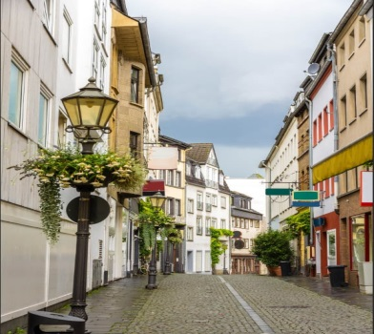

**Step 2:** Create a new layer on this layer and in properties turn on 3d moon light. Then the image will turn into darker version overall.

**Step 3:** To add moon into the sky we trim a part of the image consisting the sky and take another night sky image consisting moon

**Step 4:** Now take another colour layer for adding lights here and there .Fix this layer on the moon light layer using Alt key and then use brush and by using white colour draw lighting on the image.

**Step 5:** Take another layer and change levels and curves about blue light to make it more realistic.

**Step 6:** Adjust moon light and all and we are done.

*🡨Final*

